**ABSTRACT**

Security is prime concern in our day-to-day life. Everyone wants to be as much as secure as to be possible. An access control systems forms a vital link in a security chain. Door lock is used in doors to lock the door; it is a security strategy use for avoiding opening the door. Only an authorized and rightful person is allowed to open the door.

The Arduino controller based digital lock is an access control system that allows only authorized persons to access a restricted area. This system is best suitable for corporate offices, ATMs and home security. A knock based security system (KBSS) system uses a Piezo sensor and ARDUINO.

The project idea was to build a knock detecting door lock which can identify the specific knocking pattern and unlock the door if the pattern is correct. This door knocking system provides much security than systems which are currently using. When there are many users who use the door, problems may occur because there is only one key to open to door. But there is this door locking system this kind of problems may not occur because the users who may know the knocking pattern can open the door anytime without a key.

The aim of this project is that secret door knocker uses a piezo element to record and detect your secret knock pattern, then turns a servo motor that you can connect to your door lock. Press the button to record a knock pattern, and then test it by knocking.

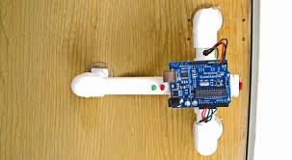

**Setup**

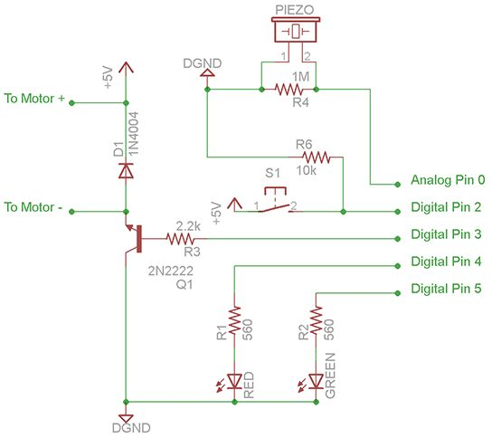

**Arduino-Secret-Knock-Detecting-Door-Lock-circuit**

**#1: Wire the Piezo Sensor**

Solder a pair of 12" (30cm) leads to the Piezo speaker. Connect it between Analog pin 0 and the ground. Also attach the 1M ohm resistor between Analog pin 0 and the ground.

**Test**: With your Arduino plugged into your computer (via USB or Serial cable) and open the Serial monitor window. (That's the button furthest to the right at the top of the Arduino development environment.) With the Arduino powered on you should see the text "Program start." Tap the piezo speaker and you should see the text "knock starting" and "knock" each time you tap it. Stop for a second or two and you'll probably see "Secret knock failed" or "Door unlocked!"  
  
If you don't see anything or see junk, make sure your serial port is set to 9600 baud and reset the power on the Arduino. If you're sure it's right, then try tapping [Shave and a Haircut](http://en.wikipedia.org/wiki/Shave_and_a_Haircut) and see if you can get the "Door unlocked!" message.  
  
If you get knock messages without tapping it may be too sensitive. If so you'll need to edit the sketch. Around line 27 raise the value of **threshold**. This can be raised as high as 1032 if you have a very sensitive detector.

**const int threshold = 3;** // Minimum signal from the piezo to register as a knock  
Once you have it working the way you want it you can comment out (or delete) the lines that start with **Serial**... We shouldn't need them any more.

**#2: Wire up the LEDs**

Lets wire up some LEDs so we don't have to use a serial cable to see what's going on.  
Connect the red LED to digital pin 4 and green LED to digital pin 5 with their corresponding 560* ohm resistors in line.

**Test**: If you power the circuit the green LED should light. If not, check your connections and make sure the LED is the right way around. Every time you tap the green led should dim. After tapping the correct sequence the green led should blink a few times. Tapping the wrong sequence should blink the red one.

If none of this happens, check the polarity on your LEDs and all of your connections.  
* Your LEDs might require different resistance.